Making a Strong Argument
Part 1 of 5 – What is Argument in Science?
Everyday, people attempt to convince others to agree with their ideas or opinions. How can you decide which ideas are strong and which are weak? How can you evaluate the ideas or opinions of others so as to make a sound decision? One way to is to evaluate whether an opinion or idea is supported by strong evidence and reasoning.
Scientific Argument – a statement that is supported by multiple pieces of measured or observed evidence and links it all together with science facts and knowledge.

DEFINITIONS
When an opinion is science-based and supported by both scientific evidence and reasoning (known science concepts), it is called a scientific argument.

Explicitly teach students WHY learning to make and evaluate an argument is important:
- Scientific Arguments are found everywhere and heard every day-part of our society (e.g. media, advertising, medicine, etc.)
- Students need to learn to recognize them and evaluate them to decide if they agree, want to buy a product, follow scientific breakthroughs, or even seek out certain medicine
- Ultimately students need to learn to make their own arguments to persuade others of their ideas
- Give a real world example of scientific arguments (“Who is the best____(basketball player, X orY).”)
Let’s watch and compare two individuals that are each making an argument to answer the question: Should runners run barefoot or with shoes? As you watch the videos think about what makes for a strong, persuasive argument. As a class you will discuss the answers to the following questions:
- What are the ideas or opinions expressed by each speaker?
- What was different in how each speaker made their case?
- Who has the strongest (more believable) argument and why?
- The speaker who is less believable, what would make his argument stronger? What is missing?

Watch Tutorial Video 2
Watch Tutorial Video 1

CLASS
Watch the videos and think about the questions above. Take notes on the videos in your student pages on the A-Scientific Argument Notes sheet. Afterwards you will discuss your answers as a class.

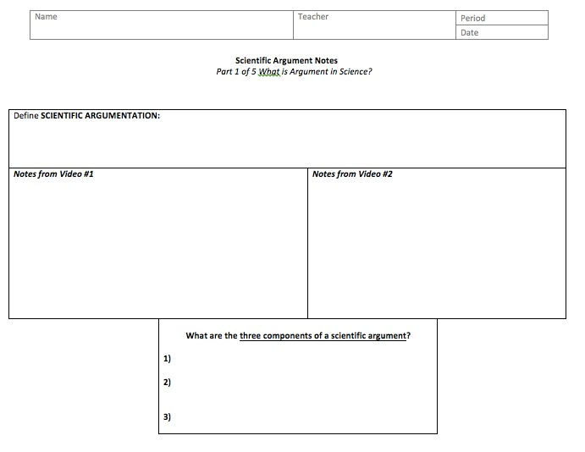

Ideas or opinions are different from arguments. Opinions are not arguments because they lack three critical components: claim, evidence, and reasoning. Similarly, a scientific argument has a science-based claim, is supported by evidence, and understood through known scientific facts (reasoning).

A scientific argument...  - ... IS NOT fighting  - ... IS NOT me against you  - ... IS NOT only based on opinions and beliefs | A scientific argument…  - ... IS presenting an idea and supporting it with evidence & facts  - ... IS found everywhere in daily life  - ... IS a way to persuade others truthfully
Emphasize Scientific Argumentation as a type of discourse where EVERYONE’s ideas are heard and respected. Setting and enforcing good classroom discussion norms or classroom rules will greatly enhance instruction of scientific argumentation. If you have a set of class rules posted in your room you might want to refer to it at this time. If you don’t or they do not emphasize listening and/or how to respond to classmates in a discussion you should set and post rules now to refer to them in future.
The Building Blocks of Scientific Argument
Scientific Argument: A set of persuading statements answering a scientific question that includes a claim supported by multiple pieces of evidence and a reasoning statement explaining what science concept links it all together.

Three Components of a Scientific Argument:

Claim:  Evidence:  Scientific Reasoning: | a statement about a phenomena or event (written as a full sentence).  a trend or pattern from measurements and observations, collected during an investigation, that supports a claim.  known science fact or knowledge that explains the connection between evidence and claim.
- Write these definitions on a post-it or poster to hang in class to refer back to throughout the year (there will be four posters all together).
As you watched the argument videos you might not have noticed when opinions were being used instead of science facts. For the next few class periods you are going to engage in a tutorial to learn how ideas can be presented and supported with facts and reasoning. You are going to learn about strong scientific arguments that are convincing to others (i.e. your classmates, teacher, and/or a city council) and how to tell them apart from opinions.
At the end of this tutorial you will be able to:
- Identify the components of a scientific argument
- Evaluate the strength of a scientific argument and its components
A good ticket out the door is to have students write down their own definition of Scientific Argument after having seen the videos and heard the definition.
Part 2 of 5 – The “Claim” of Scientific Argument
Knowing that a scientific argument must have claim, evidence and reasoning, let’s examine the first component: the claim. Claims are statements about a phenomena or event. However some claims are obviously stronger and more persuasive than others. What might make a claim stronger or more persuasive than another? Consider the claim statements from the barefoot running videos. Which claims are strong? Which are weak?
As students discuss claims ask “What do these claims have in common…all are statements. However, how do we determine which are stronger? What helps to make some stronger? Remind students of the question and ask if these claims each address the question asked? Which statements are also clear and understandable? How could the weaker claims be strengthened?
Question: Should runners run barefoot or with shoes?
- We have this idea that in order to run all you need are shoes but actually
you just need feet. Rank 2
- Barefoot running would be great if we grew up barefoot, but we didn’t so people should not run barefoot. Rank 1
- Individuals who don’t land on their heel may be less likely to experience stress injuries. Rank 3
- We weren’t born to run on pavement. Rank 4
Rank the claim statements according to their strength (1 is the strongest claim). Remember to consider the question being asked. What did they have in common?
CLASS

Strong Claim Characteristics
- Answers the question asked
- Stands alone by rephrasing the question in a complete sentence
- Explains a cause and effect (“My claim is _____ because ______.)
You might have thought that the strongest claims were complete thoughts or sounded believable. In a scientific argument, strong, persuasive claims have certain characteristics.
- Teacher write Poster or Post it the definition of claim and the three characteristics for strong claims. (You will be referring back to them so hang it in your classroom where visible)

In your student pages you will find a description of a scientific investigation conducted by students in a science classroom. It includes a chart of data collected by the students. Evaluate the strength of the students’ claim statements using the Strong Claim Characteristics as a guide.
Together as a class read the scientific investigation, the data collected, and the question being investigated found in the student pages. (OR teacher can decide to DEMO this investigation for the class)
- You may want to show an overhead of the top half of the student page and wait to hand out the full SP until you have gone over it as a class.
- Facilitating questions include:
  - “What is the definition of claim and do these claims meet it?”, “
  - Do these claims meet the characteristics of a strong claim statement?”,
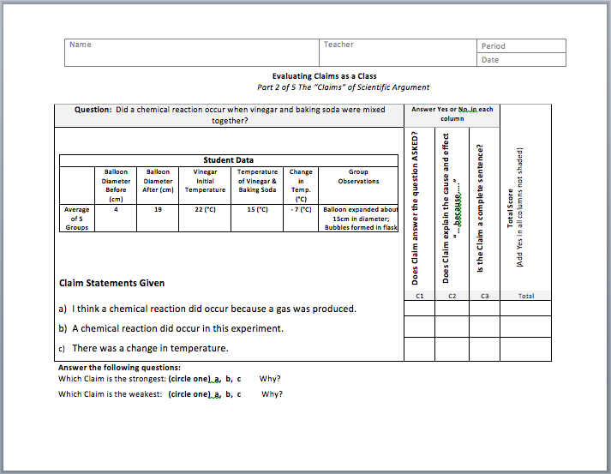
  - “Which ones and Why?
Think, Pair Share: Discuss with your group the example investigation and claims found on the B-Evaluating Claims as a Class sheet. Answer the questions that follow. Afterward discuss your answers as a class.
CLASS

Questions to consider with your group and discuss as a class:

- Which claim(s) answer the question asked?
- Which claim(s) are causal (include why or because)?
- Which claim(s) are the most clear, restating the question asked?
- Which is the best claim statement for the data provided?
- Which claim is the strongest? Why?

Did you realize that the strongest claims are those with multiple boxes checked (both answer a question AND explain a cause/effect)? The weakest claims had only one box on the table checked. On your own, analyze the claim statements from a second student investigation.
STUDENT
Evaluate the claim statements for the unknown substances investigation on the C-Evaluating Claims as an Individual sheet. Answer the questions that follow on the bottom of the sheet.
- Together as a class read the next scientific investigation the data collected, and the question being investigated FOUND IN THE STUDENT PAGES. (AND/OR teacher can decide to DEMO this investigation for the class during this discussion).
- You may want to show an overhead of the top half of the student page and wait to hand out the full SP until you have gone over it as a class.

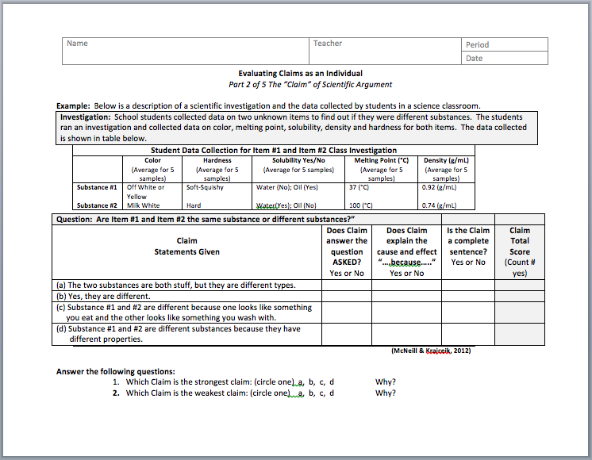
The next activity will be referred to often in the tutorial, as such is you will need to walk them through the investigation as a class.
- Be sure to answer the questions at the bottom of the student page…Which is the strongest claim and WHY (because it meets multiple characteristics that make up a strong claim—answers question asked it is causal, and it can stand alone.)

Consider this question: Which student claim in this assignment is the strongest? To help determine this, write your own claim by answering this question using the Strong Claim Characteristics as a guide. Practice writing your own claim and share it with the class. What sentence starters are helpful when writing your own claim?
- Have students fill out the Claim Notes Page. Bullet #3 is an example of a sentence starter (One example for box on SP definition page). Another possible example sentence starter is “___ occurs because____ “
STUDENT
Complete the D-Scientific Argument Notes: Claims sheet and share your claims with the class.
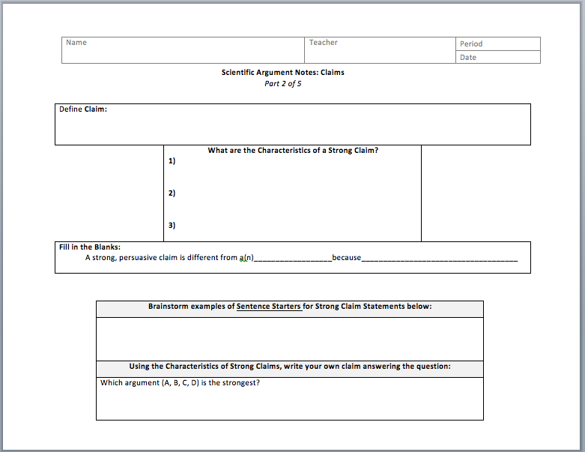

In summary, a strong persuasive claim is different from opinions or simple facts. It answers a specific question and includes a reason why the answer/solution is correct. However, a persuasive argument does not end with a claim statement, it must be supported by additional information—Evidence.
A possible ticket out the door
- “Define Claim”, or
- Write your own for “Who is the best teacher in this school?
Part 3 of 5 – The “Evidence” of Scientific Argument
Most people agree that evidence is essential to science and it is key to supporting a scientific claim. However, what counts as evidence can be confusing or hard to determine. What makes one piece of evidence stronger than another? Consider the evidence statements from the barefoot running videos. Which pieces of evidence are strong? Which are weak?
As your discuss evidence statements ask students how they define evidence
Question: Should runners run barefoot or with shoes?
- When I ran barefoot, I bruised my feet and for 8 months I had to deal with extreme pain in my feet and legs. Rank 3. (single observation..how can you make it stronger?)
- In laboratory tests of 100 runners who have never run barefoot, an average of 60% experienced a stress fracture of the foot or leg after 40 hours of running without shoes. Rank 1.
- Humans have been running for almost 2 million years and for most of that, they’ve been running barefoot. Rank 4. (This is an inference not observation)
- We studied many runners in the lab and we found that barefoot runners show less impact on their heels than shoe wearing runners. Rank 2. (General no measurements or trends in data given.)

CLASS
Rank the evidence statements according to their strength (1 is the strongest). Discuss as a class the statements that were the strong and weak. What did they have in common?

In your rankings you might have thought that many of the statements made good points and included numbers to seem stronger, but which statements were strongest?
- Were all numbers equally helpful as evidence? Why or why not?
- What did the stronger pieces of evidence have in common?

In a scientific argument, strong, persuasive evidence statements have certain characteristics.
Evidence consists of trends or patterns in your data that you can see over multiple examples. Evidence is not pure numbers, observations, or raw data. Evidence is the pattern or trend that emerges when the raw data is analyzed.
Evidence – a trend or pattern from measurements and observations, collected during an investigation, that supports a claim

Trend – the patterns in your numerical data that can be seen over multiple examples

Data – single numbers, measurements or observations from one trial
DEFINITIONS

When students begin writing their own evidence, they often use individual data points or numbers. The focus should be on patterns, statistical trends in the data.
The quality and type of evidence matters; strong evidence supports a claim and makes it more persuasive. What are the characteristics of strong evidence statements?
Strong Evidence Characteristics
- Includes trends or patterns found in data analysis (Pattern-based)
- Multiple trials/observations are reported and analyzed (Reliable)
- Evidence is scientifically correct and appropriate to the question (Accurate)
3. There are enough, more than one, pieces of appropriate evidence (Sufficient)
- Teacher write Poster or Post it the definition of Evidence and the four characteristics for strong evidence statements from above. (You will be referring back to them so hang it in your classroom where visible)
Using these Strong Evidence Characteristics as a guide, let’s compare the given evidence statements from the chemical reaction investigation and analyze each for strength.
Think, Pair, Share: Discuss with your group the evidence statements found on the E-Evaluating Evidence as a Class sheet and fill out the chart. Decide which statement is the strongest. Discuss your choice with your group then answer the questions below. Afterwards, discuss as a class.
CLASS

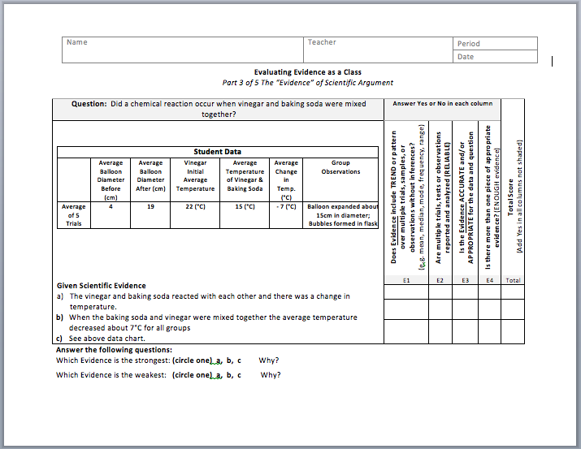
Remind students that they have just looked at this investigation/demo when discussing claims. Now they will look at evidence statements from the same investigation/demo.

Discussion Questions:
- Which evidence uses inference (speculation or generalities) and which uses measurement?
- Which evidence includes measurement trends/patterns and which evidence only states numbers?
- Which evidence statement is the strongest? Why?

Did you realize that the strongest evidence statements are those with the most boxes checked (Includes trend/pattern, is accurate and appropriate, and is sufficient in number), while the weakest evidence had only one or none boxes on the chart checked?

Previously, we compared the claims written for a classroom investigation asking the question: Is Substance #1 and Substance #2 the same substance or different substances? On your own, now analyze the students’ supporting evidence for this same investigation.
Remind students that they have just looked at this investigation/demo when discussing claims. Now they will look at evidence statements from the same investigation/demo.
On your own, review the investigation, data collected, and given claim found on the F-Evaluating Evidence as an Individual sheet. Choose the best evidence statement that supports the claim. Explain why you chose that statement.
STUDENT

- As you walk around the class, make sure the students fill out the two questions on the bottom of the rubric and answer why. Discuss as a class.

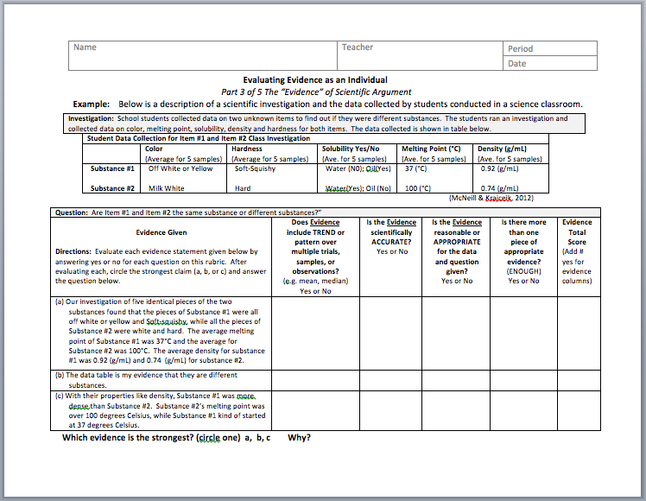
As you walk between groups ask questions: “What is the difference between evidence and raw numbers? Can you give me an example?” You may also have to remind groups how to read the investigation table to determine if the data is accurate.

Take time to go over the evidence statements as a class. Remember to refer to the definitions of claim, evidence and trend and the four characteristics of evidence.
Ask facilitating question like:

- “Why did you score it that way?”
- “What trend did you notice?”,
- “Was the evidence appropriate and in what way?”
- “What is the difference between the evidence statements?”
- “How could the evidence statements be stronger?

In summary, a strong claim with supporting evidence is different from an idea that is opinion-based. However, a persuasive scientific argument does not end with a claim and evidence. A scientific argument needs to include the link of scientific content or scientific fact—Scientific Reasoning.
STUDENT
Complete the G-Scientific Argument Notes: Evidence sheet.

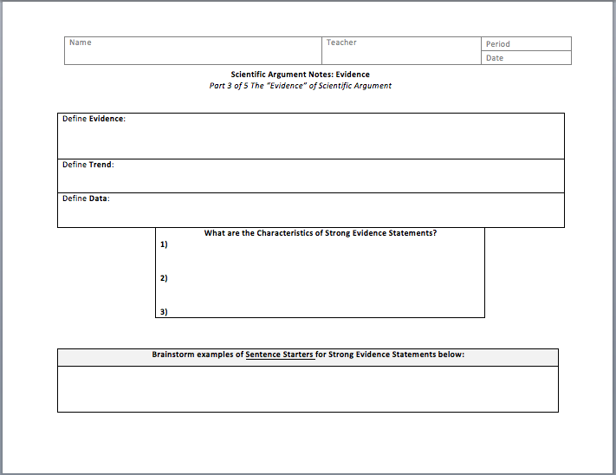
Have students look for examples of evidence sentence starters as they continue through the unit.
Examples include:
- We ran ___trials and found the following trends_____”
- “In ___repeated identical investigations we found on average that ______”
- “In our investigation we found that after analyzing five trials, a pattern emerged showing ____
- "In our experiment/investigation we found____”
- “My evidence is that____

A good ticket out the door is to have students write down their own definition of evidence and trend after having practiced identifying each.
Part 4 of 5 – The “Reasoning” of Scientific Argument
We have discussed the first two components of scientific argument: claim and evidence. Now we will address the third, and possibly the most critical, component of the scientific argument:
Scientific Reasoning.

What qualities might make some reasoning statements stronger than others? Let’s consider the reasoning statements from the barefoot running arguments. Which of the statements are strong? Which are weak? Why?
In Scientific Argumentation research studies have shown that students understand how evidence fits with a claim, but the connection of underlying scientific concepts (reasoning) with claim and evidence is the hardest. Yet scientific reasoning is the most important component of the scientific argument because it is what facilitates student sense making. It requires the understanding and application of a science concept to an investigation. As a result, time should be taken to make sure that students understand this component.
Question: Should runners run barefoot or with shoes?
- When you land on your heel there’s a rapid force created between the ground and your foot. Rank 2
- Barefoot runners land toward the front of their foot and then let the heel come down afterwards, which is different than runners wearing shoes, so it is better. (Rank 3. None)
- Science has showed that doing the same motion over and over can cause stress to the human body. Running causes repeated strikes (over and over) on the heel of the foot on pavement and thus can result in stress to the body. Rank 1 (strong logic as it follows the template “In science we have learned that ____and because of this_____, then____, therefore____”)
Rank the reasoning statements according to their strength (1 is the strongest). Discuss as a class the statements that were strong and weak. What did they have in common?
CLASS

In your rankings of the reasoning statements, you might have thought that many had valid points, but were some stronger than others?
- What did the stronger reasoning statements have in common?
- What type of vocabulary did the stronger reasoning statements use?
- Was there a connection to the original claim or idea?
Scientific reasoning gives an argument its strength. Scientific reasoning explains why; what it all means. The reasoning explains the science that was occurring and what it means to the question. Specifically, the reasoning is the science content or facts that links the evidence to the claim you made.
Reasoning – The justification that links the evidence to the claim. It explains why the evidence supports the claim.

Scientific Reasoning – The justification that links the evidence to the claim. It explains why the evidence supports the claim. It is a description of known science fact or knowledge that explains the connection between given evidence and a claim.

DEFINITIONS

Strong Scientific Reasoning Characteristics
1. Includes appropriate science vocabulary or terms
2. Completely explains the science facts (big idea) that connect the evidence and claim
3. Answers why and/or how the patterns of evidence occurred and support the claim

Strong reasoning links a claim and evidence, giving an argument justification and context within the natural world. What are the characteristics of strong reasoning statements?
Teacher create Poster or Post it with the definition of Reasoning and the three characteristics for strong reasoning statements. (You will be referring back to them so hang it in your classroom where visible)

Let’s compare and analyze the reasoning statements for the chemical reaction investigation.
Analyze the student’s scientific reasoning for this investigation using the Strong Scientific Reasoning Characteristics as a guide.
Think, Pair, Share: Discuss with your group the reasoning statements found on the H-Evaluating Reasoning as a Class sheet. Fill out the chart individually. Decide which statement is the strongest, and discuss you choice with your group.
CLASS

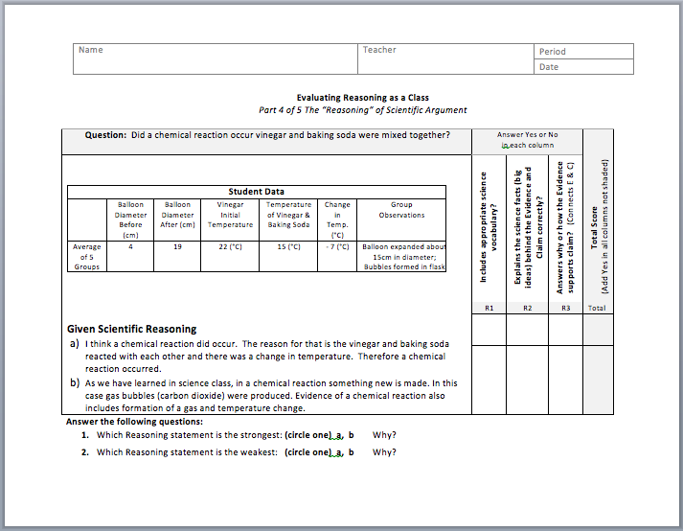
Take time to go over the reasoning statements as a class. Remember to refer to the definition of reasoning and the three characteristics of reasoning. Ask facilitating questions like: “Do these reasoning statements fit with the definition and characteristics of strong reasoning?”, “Do these reasoning statements fit with your understanding of the science of chemical reactions? Are the big science ideas clearly expressed?

During discussion remember to ask students to elaborate on their thinking. Ask questions like “Why do you think that?”, “Does anyone disagree with that?” and “Why?”
Discussion Questions:
- Which statement(s) used appropriate science vocabulary?
- Was a scientific “Big Idea” explained?
- Which statement(s) linked the claim and evidence?
- Which reasoning statement is the strongest? Why?
Once again you should have noticed that the strongest reasoning statements are those with the most boxes checked (appropriate science vocabulary, scientific big idea explanation, explaining why or how the big idea connects the evidence and claim) and the weakest reasoning had none or one box on the rubric checked.

Previously, you compared the claims and supporting evidence written after a classroom investigation that asked the question: Is Substance #1 and Substance #2 the same substance or different substances? On your own, now analyze students’ scientific reasoning for this same investigation.
STUDENT
Review the investigation, data collected, given claim and evidence found on the I-Evaluating Reasoning as an Individual sheet. Choose the best reasoning statement. Explain why you chose that statement.

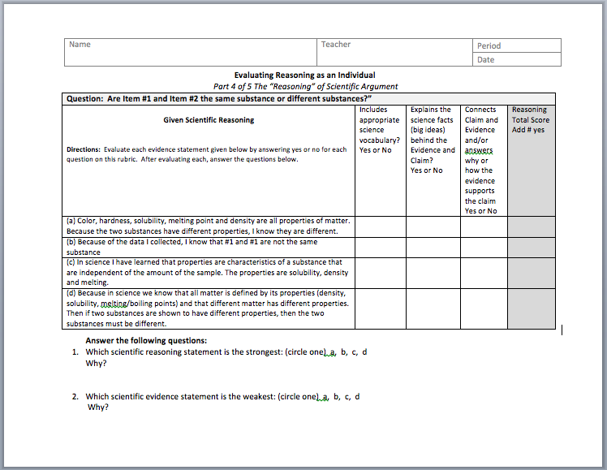

As you walk around the class, make sure the students fill out the two questions on the bottom of the rubric and answer why. Discuss this as a class.

In summary, strong scientific arguments are persuasive and include three critical components: claims, evidence, and reasoning. The quality of these three components strengthens the argument that is answering a scientific question. You will now record notes on scientific reasoning and afterward you will put it all together and evaluate whole arguments for strength.
Complete the J-Scientific Argument Notes: Reasoning sheet.
STUDENT

Have students write the definitions for Reasoning in their student pages. Also have them look for examples of reasoning sentence starters as they continue through the unit. (TE includes this list). Some examples include:
  - "Because in Science…"
  - “We have learned in science that _____”
  - “Science shows us that______”
Claim + Evidence
+ Scientific Reasoning
What do you know?
= Scientific Argument
How do you know that?
Why does your evidence support your claim?

A good ticket out the door is to have students write their own definition of scientific reasoning after having identified it and practiced evaluating it.
Part 5 of 5 - Evaluating Complete Scientific Arguments
In this tutorial you have learned to identify the components of a strong scientific argument (claim, evidence, and reasoning) and to evaluate the strength of each component individually. Now we will put it all together and evaluate arguments as a whole.
As a class, lets look at the following student arguments. These were written after the students completed an investigation in class to answer the question “How does exercise affect your pulse rate?”. Identify the individual components of the student’s argument (underline the claim, number the pieces of evidence, and circle the reasoning statement) and evaluate the strength of each. Ultimately, you will compare the two arguments and determine which is stronger and why?
Read the arguments as a class. Have the class identify the claim and evidence statements (and ask what is left over). Introduce the underline, number, circle method of identifying the components of claim and evidence here by placing the two arguments on an overhead and as students identify each then underline the claim, number the evidence…at end circle the reasoning as being the difference between the two arguments (this is the key to this exercise-to identify what is missing, the reasoning). Explicitly tell students that this underline, number and circle method is a way to graphically identify the pieces of a scientific argument and they will be practicing it.
Think, Pair, Share: Identify the components of the argument (claim, evidence, and reasoning). Then use the rubric on the K-Evaluating an Argument as a Class sheet to evaluate the quality of each component. Answer the questions that follow the second argument.
CLASS
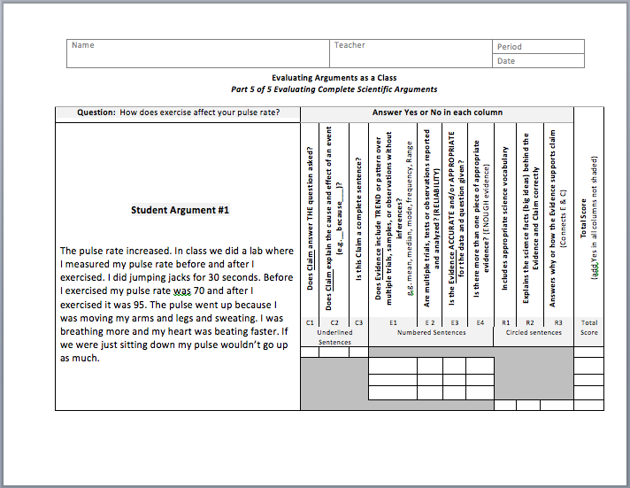
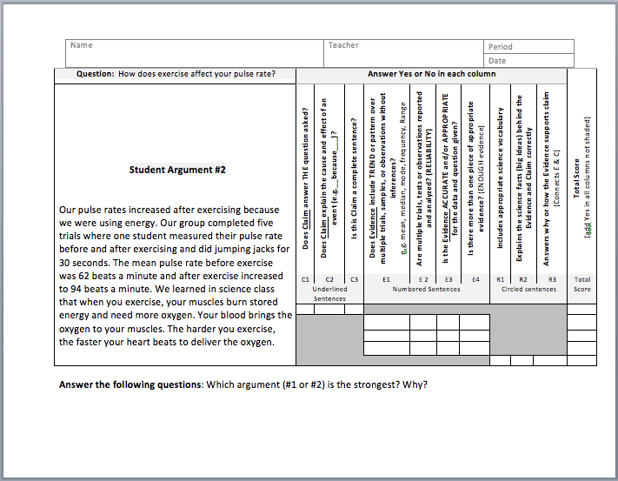
As you walk around the class, make sure the students fill out the two questions on the bottom of the rubric and answer why. Discuss as class.
Discussion Questions for Each Argument:
- Are you persuaded to the writer’s way of thinking? Why or why not?
- Does it meet the characteristics of each component of an argument?
- Is the evidence appropriate and/or logical with the claim?
- How can you improve the weaker argument?
During discussion remember to ask students to elaborate on their thinking. Ask questions like “Why do you think that?”, “Does anyone disagree with that?” and “Why?”, “Does this science reasoning fit with your understanding of the process of science?
Now that you have evaluated an argument as a class (identifying the components and determining their argumentative strength), you are going to try it on your own. In your student pages you will find two different arguments for the question “Why do you think penguins are able to survive in their natural environment?” Read, compare, and evaluate each of the arguments for strength. Determine which one is the stronger argument and why.
STUDENT
Compare and evaluate the scientific arguments found on the L-Evaluating Arguments as an Individual sheet. Identifying the components of each argument, then rank each on the rubric. Answer the questions that follow the second argument.

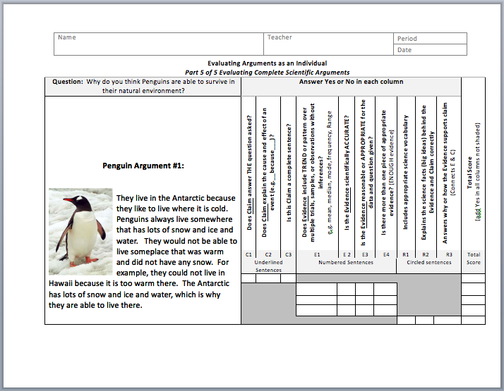
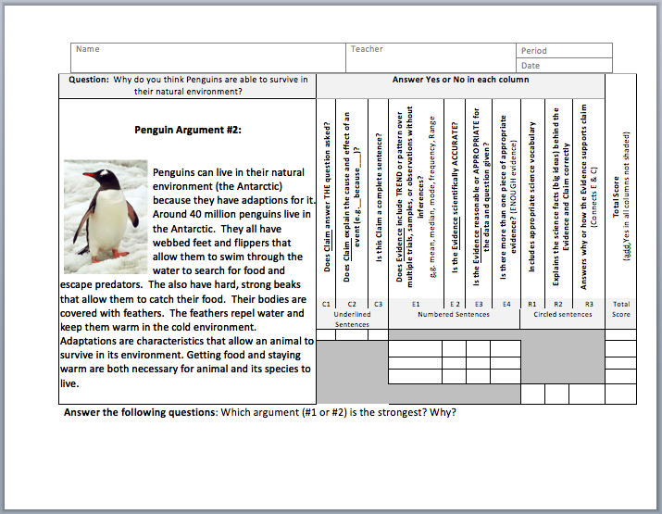

Making an argument is one of the fundamental things we do as a society. People make arguments everyday. Basic argumentation means claiming that something is true and trying to persuade others to agree with your claim by presenting evidence and reasoning to support it.

Learning to identify and evaluate strong arguments is important for all citizens. Not only do scientists make arguments based on science, engineers do as well. Solutions in engineering are informed by scientific evidence and reasoning and presented to clients through argumentation. Through this tutorial you have learned how to identify and evaluate strong scientific arguments. This will help you increase your critical thinking skills and become a well-informed citizen.

